WELCOME TO TRAVELLO

**HANDCRAFTED BY ROHIT PATIL**



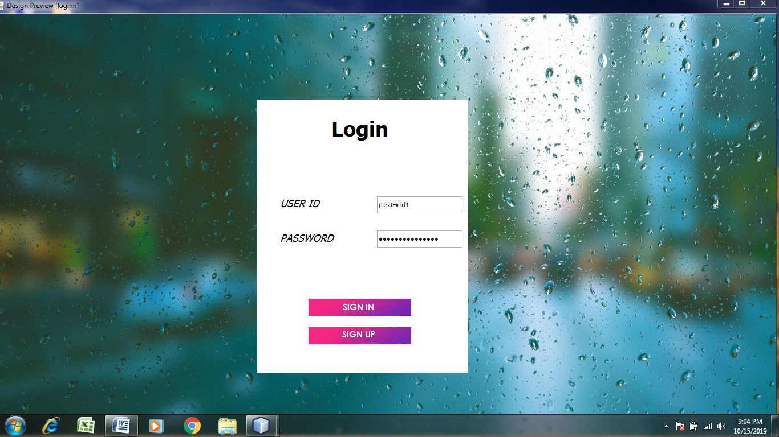LOGIN DESIGN AND CODING

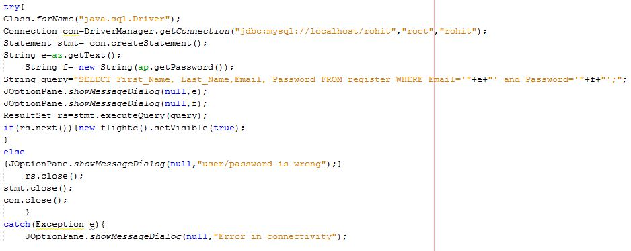

**REGISTER FORM DESIGN, CODING AND OUTPUT**

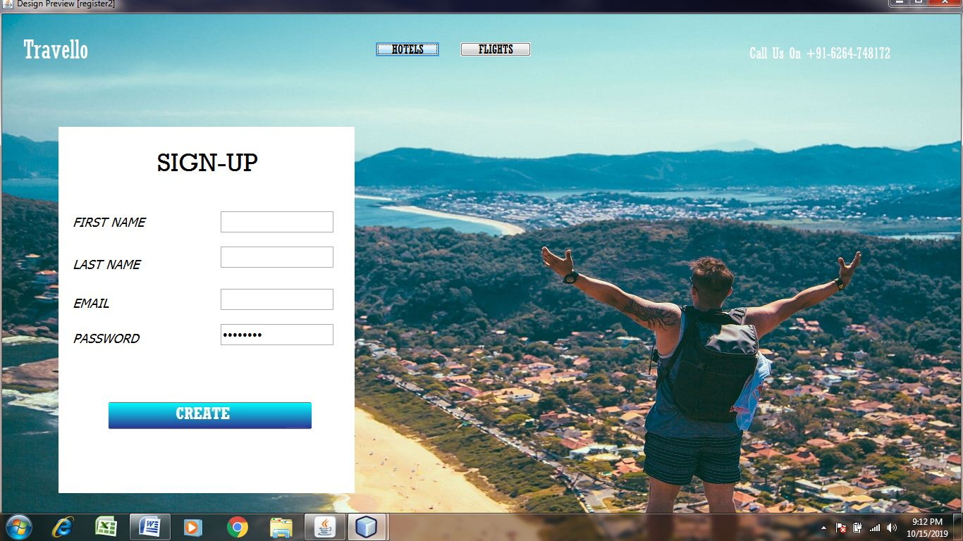

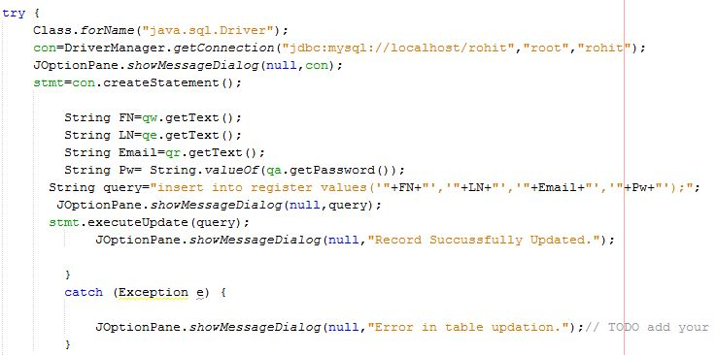

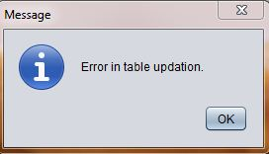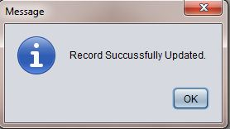IF IT CONTAINS ERROR IF IT CONTAINS NO ERROR

WEBPAGE FOR

SEARCHING AND

BOOKING FLIGHTS



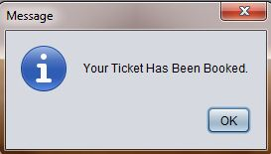

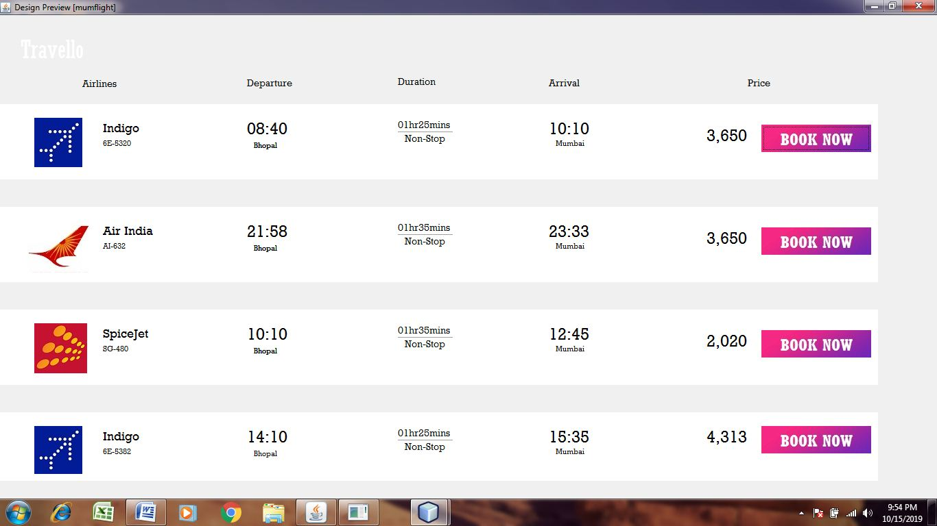DOMESTIC FLIGHTS

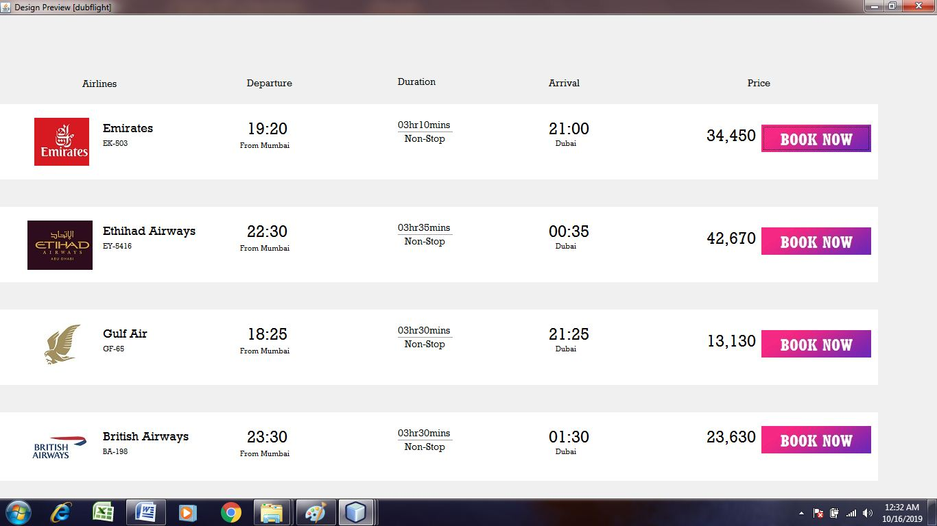INTERNATIONAL FLIGHTS

WEBPAGE FOR

SEARCHING AND

BOOKING HOTELS



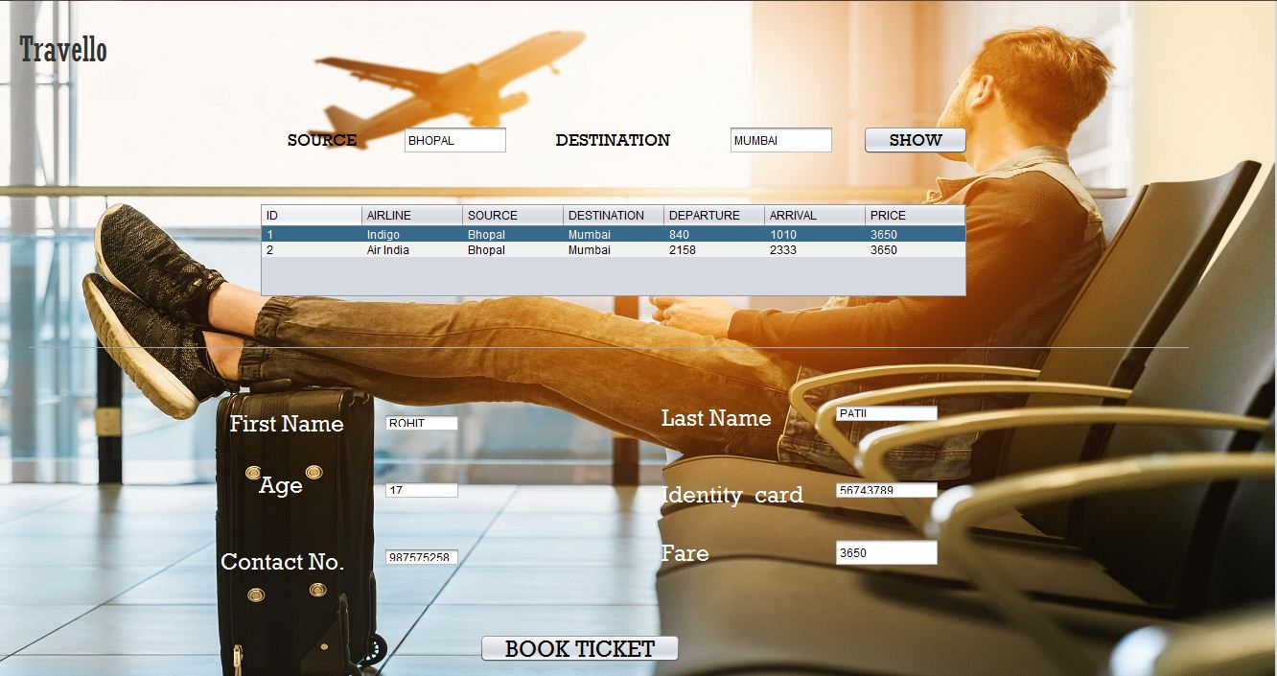FLIGHT BOOKING

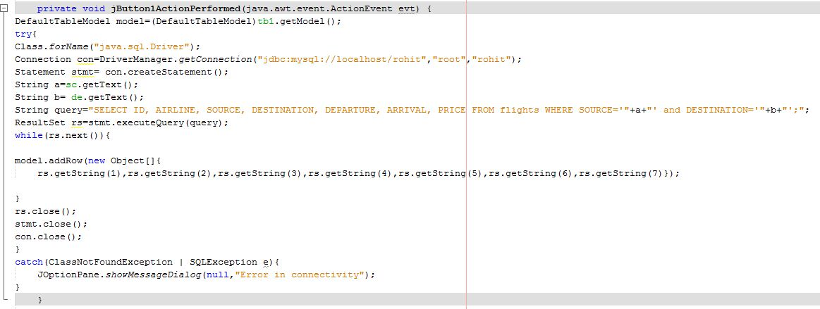

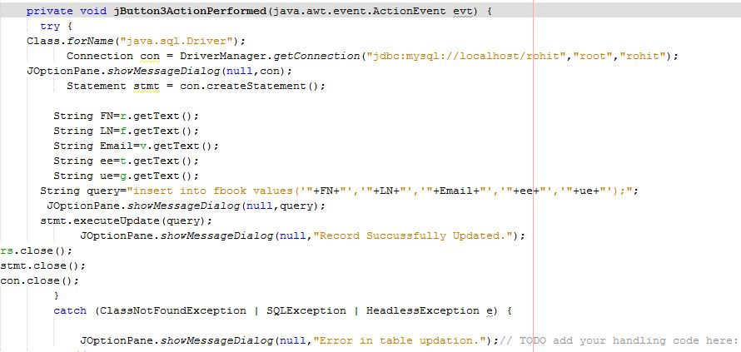

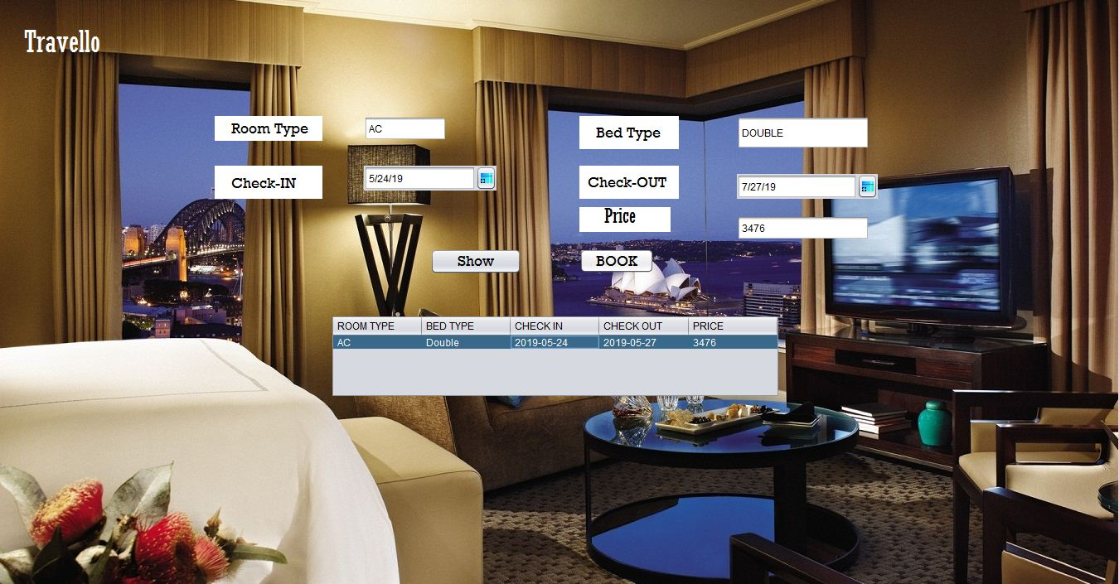HOTEL BOOKING

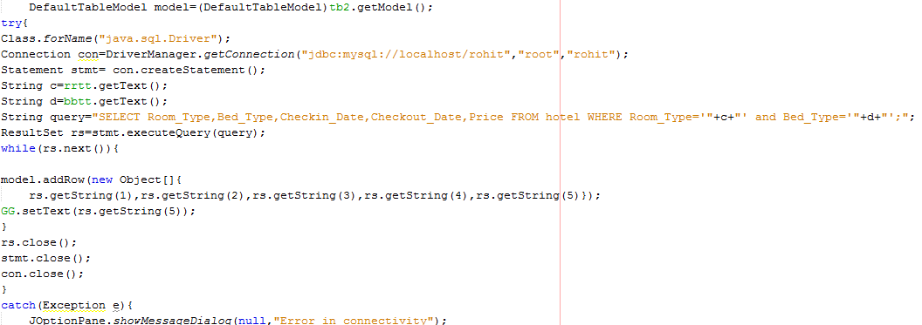



TABLE STRUCTURE OF REPORT

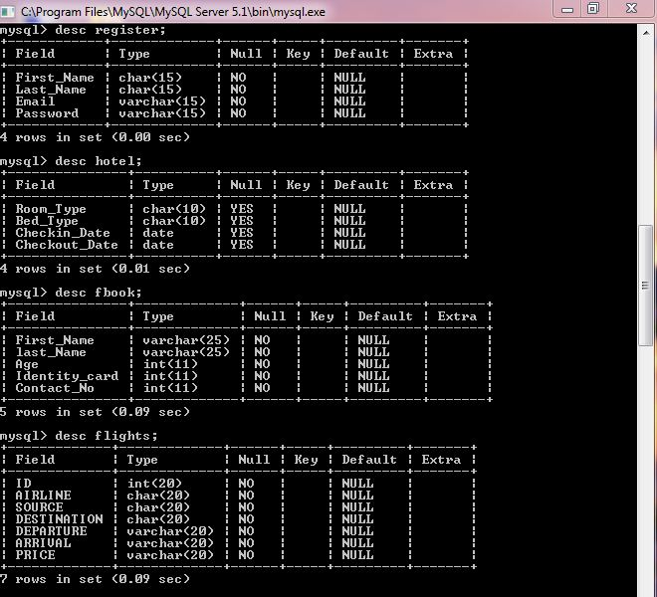



INFORMATICS

PRACTICES

PROJECT

______________________________________________________________________________________________________

TRAVEL AGENCY

SESSION: 2019-2020

SUBMITTED TO- SUBMITTED BY-MRS. KANIKA SHARMA ROHIT PATIL

CODING FOR GET IN

BUTTON

private void jButton1ActionPerformed(java.awt.event.ActionEvent evt) {

new loginn().setVisible(true);

this.dispose();

CODING FOR FLIGHT FORM

private void jButton2ActionPerformed(java.awt.event.ActionEvent evt) {

new hotelss().setVisible(true);

this.dispose();// TODO add your handling code here:

}

private void cbItemStateChanged(java.awt.event.ItemEvent evt) {

// TODO add your handling code here:

}

private void cbActionPerformed(java.awt.event.ActionEvent evt) {

// TODO add your handling code here:

}

private void jButton1ActionPerformed(java.awt.event.ActionEvent evt) {

{if(cb.getSelectedItem()=="Mumbai")

new mumflight().setVisible(true);}

{if(cb.getSelectedItem()=="Dubai")

new dubflight().setVisible(true);} // TODO add your handling code here:

}

private void jButton4ActionPerformed(java.awt.event.ActionEvent evt) {

new flbooking().setVisible(true); // TODO add your handling code here:

}

private void jButton5ActionPerformed(java.awt.event.ActionEvent evt) {

// TODO add your handling code here:

}

private void jButton8ActionPerformed(java.awt.event.ActionEvent evt) {

new front().setVisible(true); // TODO add your handling code here:

}

CODING FOR INTERNATIONAL FLIGHTS

private void jButton2ActionPerformed(java.awt.event.ActionEvent evt) {

new flbooking().setVisible(true); // TODO add your handling code here:

}

private void jButton1ActionPerformed(java.awt.event.ActionEvent evt) {

new flbooking().setVisible(true); // TODO add your handling code here:

}

private void jButton3ActionPerformed(java.awt.event.ActionEvent evt) {

new flbooking().setVisible(true); // TODO add your handling code here:

}

private void jButton4ActionPerformed(java.awt.event.ActionEvent evt) {

new flbooking().setVisible(true); // TODO add your handling code here:

}

CODING FOR DOMESTIC FLIGHTS

private void bn1ActionPerformed(java.awt.event.ActionEvent evt) {

new flbooking().setVisible(true);

// TODO add your handling code here:

}

private void jButton1ActionPerformed(java.awt.event.ActionEvent evt) {

new flbooking().setVisible(true); // TODO add your handling code here:

}

private void jButton3ActionPerformed(java.awt.event.ActionEvent evt) {

new flbooking().setVisible(true); // TODO add your handling code here:

}

private void jButton4ActionPerformed(java.awt.event.ActionEvent evt) {

new flbooking().setVisible(true); // TODO add your handling code here:

}

CODING FOR HOTEL FORM

private void jButton2ActionPerformed(java.awt.event.ActionEvent evt) {

new hotelss().setVisible(true); // TODO add your handling code here:

}

private void jButton1ActionPerformed(java.awt.event.ActionEvent evt) {

new hotel1().setVisible(true); // TODO add your handling code here:

}

private void jButton8ActionPerformed(java.awt.event.ActionEvent evt) {

new front().setVisible(true); // TODO add your handling code here:

}

IMPORT CODING

import java.sql.*;

import javax.swing.JOptionPane;

NEW FORM CODING

private void suActionPerformed(java.awt.event.ActionEvent evt) {

new register2().setVisible(true);

this.dispose();

IMPORT CODING

import java.awt.Color;

import java.sql.*;

import javax.swing.table.DefaultTableModel;

import javax.swing.JOptionPane;

NEW FORM CODING

private void registerbtnActionPerformed(java.awt.event.ActionEvent evt) {

new flightc().setVisible(true);

this.dispose();

private void jButton3ActionPerformed(java.awt.event.ActionEvent evt) {

new flightc().setVisible(true);

IMPORT CODING

import java.awt.HeadlessException;

import java.sql.*;

import javax.swing.table.DefaultTableModel;

import javax.swing.JOptionPane;

NEW FORM CODING

private void jButton2ActionPerformed(java.awt.event.ActionEvent evt) {

new hotelss().setVisible(true); // TODO add your handling code here:

}

private void jButton8ActionPerformed(java.awt.event.ActionEvent evt) {

new front().setVisible(true);

IMPORT CODING

import java.sql.*;

import javax.swing.table.DefaultTableModel;

import javax.swing.JOptionPane;

NEW FORM CODING

private void jButton3ActionPerformed(java.awt.event.ActionEvent evt) {

new hotelss().setVisible(true); // TODO add your handling code here:

}

private void jButton8ActionPerformed(java.awt.event.ActionEvent evt) {

new front().setVisible(true);

public class register2 extends javax.swing.JFrame {

Connection con=null;

Statement stmt=null;

ResultSet rs=null;

public register2() {

initComponents();

setExtendedState(register2.MAXIMIZED_BOTH);

jPanel1.setBackground(new Color(255,255,255,200));

}

public class flbooking extends javax.swing.JFrame {

Connection con=null;

Statement stmt=null;

ResultSet rs=null;

public flbooking() {

initComponents();

setExtendedState(flbooking.MAXIMIZED_BOTH);

}

public class hotel1 extends javax.swing.JFrame {

public hotel1() {

initComponents();

setExtendedState(hotel1.MAXIMIZED_BOTH);

}

Q20.

mysql> create table CLUB(

    -> C_Id INT(10) PRIMARY KEY,

    -> Coach_Name VARCHAR(40),

    -> Age INT(5),

    -> Sports VARCHAR(30),

    -> DateofApp DATE,

    -> Pay INT(10),

    -> Sex CHAR(1),

    -> No_players INT(10));

Query OK, 0 rows affected (0.02 sec)

mysql> insert into CLUB values(

    -> 1, 'KUKREJA', 35, 'KARATE', '2012-03-27', 1000, 'M', 20),

    -> (2, 'RAVINA', 34, 'KARATE', '2008-01-20', 1200, 'F', 15),

    -> (3, 'KARAN', 34, 'SQUASH', '2009-02-19', 2000, 'M', 2),

    -> (4, 'TARUN', 33, 'BASKETBALL', '2012-01-01', 1500, 'M', 16),

    -> (5, 'ZUBIN', 36, 'SWIMMING', '2008-01-12', 700, 'M', 10);

Query OK, 5 rows affected (0.01 sec)

Records: 5  Duplicates: 0  Warnings: 0

mysql> insert into CLUB values(

    -> 6, 'KETAKI', 36, 'SWIMMING', '2012-02-24', 800, 'F', 10),

    -> (7, 'ANKITA', 39, 'SQUASH', '2013-02-20', 2200, 'F', 5),

    -> (8, 'ZAREEN', 37, 'KARATE', '2010-02-22', 1100, 'M', 18),

    -> (9, 'KUSH', 41, 'SWIMMING', '2008-01-13', 900, 'M', 17),

    -> (10, 'SHAILYA', 37, 'BASKETBALL', '2008-02-19', 1700, 'M', 17);

Query OK, 5 rows affected (0.02 sec)

Records: 5  Duplicates: 0  Warnings: 0

mysql> SELECT*FROM CLUB;

+------+------------+------+------------+------------+------+------+------------+

| C_Id | Coach_Name | Age  | Sports     | DateofApp  | Pay  | Sex  | No_players |

+------+------------+------+------------+------------+------+------+------------+

|    1 | KUKREJA    |   35 | KARATE     | 2012-03-27 | 1000 | M    |         20 |

|    2 | RAVINA     |   34 | KARATE     | 2008-01-20 | 1200 | F    |         15 |

|    3 | KARAN      |   34 | SQUASH     | 2009-02-19 | 2000 | M    |          2 |

|    4 | TARUN      |   33 | BASKETBALL | 2012-01-01 | 1500 | M    |         16 |

|    5 | ZUBIN      |   36 | SWIMMING   | 2008-01-12 |  700 | M    |         10 |

|    6 | KETAKI     |   36 | SWIMMING   | 2012-02-24 |  800 | F    |         10 |

|    7 | ANKITA     |   39 | SQUASH     | 2013-02-20 | 2200 | F    |          5 |

|    8 | ZAREEN     |   37 | KARATE     | 2010-02-22 | 1100 | M    |         18 |

|    9 | KUSH       |   41 | SWIMMING   | 2008-01-13 |  900 | M    |         17 |

|   10 | SHAILYA    |   37 | BASKETBALL | 2008-02-19 | 1700 | M    |         17 |

+------+------------+------+------------+------------+------+------+------------+

10 rows in set (0.00 sec)

ysql> /*a*/SELECT*FROM CLUB WHERE Sports='SWIMMING';

+------+------------+------+----------+------------+------+------+------------+

| C_Id | Coach_Name | Age  | Sports   | DateofApp  | Pay  | Sex  | No_players |

+------+------------+------+----------+------------+------+------+------------+

|    5 | ZUBIN      |   36 | SWIMMING | 2008-01-12 |  700 | M    |         10 |

|    6 | KETAKI     |   36 | SWIMMING | 2012-02-24 |  800 | F    |         10 |

|    9 | KUSH       |   41 | SWIMMING | 2008-01-13 |  900 | M    |         17 |

+------+------------+------+----------+------------+------+------+------------+

3 rows in set (0.00 sec)

mysql> /*b*/SELECT*FROM CLUB WHERE Coach_Name LIKE 'K%';

+------+------------+------+----------+------------+------+------+------------+

| C_Id | Coach_Name | Age  | Sports   | DateofApp  | Pay  | Sex  | No_players |

+------+------------+------+----------+------------+------+------+------------+

|    1 | KUKREJA    |   35 | KARATE   | 2012-03-27 | 1000 | M    |         20 |

|    3 | KARAN      |   34 | SQUASH   | 2009-02-19 | 2000 | M    |          2 |

|    6 | KETAKI     |   36 | SWIMMING | 2012-02-24 |  800 | F    |         10 |

|    9 | KUSH       |   41 | SWIMMING | 2008-01-13 |  900 | M    |         17 |

+------+------------+------+----------+------------+------+------+------------+

4 rows in set (0.01 sec)

mysql> /*c*/ SELECT*FROM CLUB ORDER BY Coach_Name asc;

+------+------------+------+------------+------------+------+------+------------+

| C_Id | Coach_Name | Age  | Sports     | DateofApp  | Pay  | Sex  | No_players |

+------+------------+------+------------+------------+------+------+------------+

|    7 | ANKITA     |   39 | SQUASH     | 2013-02-20 | 2200 | F    |          5 |

|    3 | KARAN      |   34 | SQUASH     | 2009-02-19 | 2000 | M    |          2 |

|    6 | KETAKI     |   36 | SWIMMING   | 2012-02-24 |  800 | F    |         10 |

|    1 | KUKREJA    |   35 | KARATE     | 2012-03-27 | 1000 | M    |         20 |

|    9 | KUSH       |   41 | SWIMMING   | 2008-01-13 |  900 | M    |         17 |

|    2 | RAVINA     |   34 | KARATE     | 2008-01-20 | 1200 | F    |         15 |

|   10 | SHAILYA    |   37 | BASKETBALL | 2008-02-19 | 1700 | M    |         17 |

|    4 | TARUN      |   33 | BASKETBALL | 2012-01-01 | 1500 | M    |         16 |

|    8 | ZAREEN     |   37 | KARATE     | 2010-02-22 | 1100 | M    |         18 |

|    5 | ZUBIN      |   36 | SWIMMING   | 2008-01-12 |  700 | M    |         10 |

+------+------------+------+------------+------------+------+------+------------+

10 rows in set (0.01 sec)

mysql> /*d*/SELECT*FROM CLUB ORDER BY DateofApp DESC;

+------+------------+------+------------+------------+------+------+------------+

| C_Id | Coach_Name | Age  | Sports     | DateofApp  | Pay  | Sex  | No_players |

+------+------------+------+------------+------------+------+------+------------+

|    7 | ANKITA     |   39 | SQUASH     | 2013-02-20 | 2200 | F    |          5 |

|    1 | KUKREJA    |   35 | KARATE     | 2012-03-27 | 1000 | M    |         20 |

|    6 | KETAKI     |   36 | SWIMMING   | 2012-02-24 |  800 | F    |         10 |

|    4 | TARUN      |   33 | BASKETBALL | 2012-01-01 | 1500 | M    |         16 |

|    8 | ZAREEN     |   37 | KARATE     | 2010-02-22 | 1100 | M    |         18 |

|    3 | KARAN      |   34 | SQUASH     | 2009-02-19 | 2000 | M    |          2 |

|   10 | SHAILYA    |   37 | BASKETBALL | 2008-02-19 | 1700 | M    |         17 |

|    2 | RAVINA     |   34 | KARATE     | 2008-01-20 | 1200 | F    |         15 |

|    9 | KUSH       |   41 | SWIMMING   | 2008-01-13 |  900 | M    |         17 |

|    5 | ZUBIN      |   36 | SWIMMING   | 2008-01-12 |  700 | M    |         10 |

+------+------------+------+------------+------------+------+------+------------+

10 rows in set (0.00 sec)

mysql> /*e*/SELECT Coach_Name, Age, Sex FROM CLUB WHERE Sex='M';

+------------+------+------+

| Coach_Name | Age  | Sex  |

+------------+------+------+

| KUKREJA    |   35 | M    |

| KARAN      |   34 | M    |

| TARUN      |   33 | M    |

| ZUBIN      |   36 | M    |

| ZAREEN     |   37 | M    |

| KUSH       |   41 | M    |

| SHAILYA    |   37 | M    |

+------------+------+------+

7 rows in set (0.00 sec)

mysql> /*f*/SELECT*FROM CLUB WHERE Age>35 AND Pay BETWEEN 1500 AND 2000;

+------+------------+------+------------+------------+------+------+------------+

| C_Id | Coach_Name | Age  | Sports     | DateofApp  | Pay  | Sex  | No_players |

+------+------------+------+------------+------------+------+------+------------+

|   10 | SHAILYA    |   37 | BASKETBALL | 2008-02-19 | 1700 | M    |         17 |

+------+------------+------+------------+------------+------+------+------------+

1 row in set (0.01 sec)

mysql> /*g*/SELECT Coach_Name, Pay, Age, Pay*3/20 AS BONUS FROM CLUB;

+------------+------+------+----------+

| Coach_Name | Pay  | Age  | BONUS    |

+------------+------+------+----------+

| KUKREJA    | 1000 |   35 | 150.0000 |

| RAVINA     | 1200 |   34 | 180.0000 |

| KARAN      | 2000 |   34 | 300.0000 |

| TARUN      | 1500 |   33 | 225.0000 |

| ZUBIN      |  700 |   36 | 105.0000 |

| KETAKI     |  800 |   36 | 120.0000 |

| ANKITA     | 2200 |   39 | 330.0000 |

| ZAREEN     | 1100 |   37 | 165.0000 |

| KUSH       |  900 |   41 | 135.0000 |

| SHAILYA    | 1700 |   37 | 255.0000 |

+------------+------+------+----------+

10 rows in set (0.00 sec)

mysql> /*h*/SELECT DISTINCT Sports FROM CLUB;

+------------+

| Sports     |

+------------+

| KARATE     |

| SQUASH     |

| BASKETBALL |

| SWIMMING   |

+------------+

4 rows in set (0.01 sec)

mysql> SELECT COUNT(CoachName) FROM CLUB;

ERROR 1054 (42S22): Unknown column 'CoachName' in 'field list'

mysql> SELECT COUNT(Coach_Name) FROM CLUB;

+-------------------+

| COUNT(Coach_Name) |

+-------------------+

|                10 |

+-------------------+

1 row in set (0.00 sec)

mysql> /*i*/SELECT COUNT(Coach_Name) FROM CLUB;

+-------------------+

| COUNT(Coach_Name) |

+-------------------+

|                10 |

+-------------------+

1 row in set (0.00 sec)

mysql> /*j*/SELECT COUNT(Coach_Name) FROM CLUB WHERE Sports='KARATE' AND Sports='SQUASH' AND Sports='BasketBall';

+-------------------+

| COUNT(Coach_Name) |

+-------------------+

|                 0 |

+-------------------+

1 row in set (0.00 sec)

mysql> /*j*/SELECT COUNT(Coach_Name) FROM CLUB WHERE Sports='KARATE';

+-------------------+

| COUNT(Coach_Name) |

+-------------------+

|                 3 |

+-------------------+

1 row in set (0.00 sec)

mysql> /*j*/SELECT COUNT(Coach_Name) FROM CLUB WHERE Sports='SQUASH';

+-------------------+

| COUNT(Coach_Name) |

+-------------------+

|                 2 |

+-------------------+

1 row in set (0.00 sec)

mysql> /*j*/SELECT COUNT(Coach_Name) FROM CLUB WHERE Sports='BASKETBALL';

+-------------------+

| COUNT(Coach_Name) |

+-------------------+

|                 2 |

+-------------------+

1 row in set (0.00 sec)

mysql> /*j*/SELECT COUNT(Coach_Name) FROM CLUB WHERE Sports='SWIMMING';

+-------------------+

| COUNT(Coach_Name) |

+-------------------+

|                 3 |

+-------------------+

1 row in set (0.00 sec)

mysql> /*k*/SELECT SUM(Pay) FROM CLUB WHERE Sports='KARATE';

+----------+

| SUM(Pay) |

+----------+

|     3300 |

+----------+

1 row in set (0.00 sec)

mysql> /*k*/SELECT SUM(Pay) FROM CLUB WHERE Sports='SQUASH';

+----------+

| SUM(Pay) |

+----------+

|     4200 |

+----------+

1 row in set (0.00 sec)

mysql> /*k*/SELECT SUM(Pay) FROM CLUB WHERE Sports='BASKETBALL';

+----------+

| SUM(Pay) |

+----------+

|     3200 |

+----------+

1 row in set (0.00 sec)

mysql> /*k*/SELECT SUM(Pay) FROM CLUB WHERE Sports='SWIMMING';

+----------+

| SUM(Pay) |

+----------+

|     2400 |

+----------+

1 row in set (0.00 sec)

mysql> /*L*/SELECT MAX(Age) AS AGE, MIN(Pay) AS PAY FROM CLUB;

+------+------+

| AGE  | PAY  |

+------+------+

|   41 |  700 |

+------+------+

1 row in set (0.00 sec)

mysql>/*M i*/ SELECT COUNT(Distinct Sports) FROM CLUB;

+------------------------+

| COUNT(Distinct Sports) |

+------------------------+

|                      4 |

+------------------------+

1 row in set (0.01 sec)

mysql>/*M ii*/ SELECT MIN(Age) FROM CLUB WHERE Sex="F";

+----------+

| MIN(Age) |

+----------+

|       34 |

+----------+

1 row in set (0.00 sec)

mysql>/*M iii*/ SELECT AVG(Pay) FROM CLUB WHERE Sports='KARATE';

+-----------+

| AVG(Pay)  |

+-----------+

| 1100.0000 |

+-----------+

1 row in set (0.00 sec)

mysql>/*M iv*/ SELECT SUM(Pay) FROM CLUB WHERE DateofApp>"2008-01-31";

+----------+

| SUM(Pay) |

+----------+

|    10300 |

+----------+

1 row in set (0.01 sec)

mysql>/*M v*/ SELECT Sports FROM CLUB WHERE Pay BETWEEN 700 AND 1000;

+----------+

| Sports   |

+----------+

| KARATE   |

| SWIMMING |

| SWIMMING |

| SWIMMING |

+----------+

4 rows in set (0.00 sec)

mysql>/*M vi*/ SELECT Sports FROM CLUB WHERE Pay IN(900,1000,2000);

+----------+

| Sports   |

+----------+

| KARATE   |

| SQUASH   |

| SWIMMING |

+----------+

3 rows in set (0.01 sec)

mysql>/*M vii THIS ONE IS NOT SURE, THERE WAS AN ERROR*/  SELECT Sports, SUM(Pay) FROM CLUB GROUP BY Sports HAVING Sex='M';

ERROR 1054 (42S22): Unknown column 'Sex' in 'having clause'

mysql>/*o*/ DELETE FROM CLUB WHERE Pay<1000;

Query OK, 3 rows affected (0.01 sec)

mysql>/*o*/ select*from CLUB;

+------+------------+------+------------+------------+------+------+------------+

| C_Id | Coach_Name | Age  | Sports     | DateofApp  | Pay  | Sex  | No_players |

+------+------------+------+------------+------------+------+------+------------+

|    1 | KUKREJA    |   35 | KARATE     | 2012-03-27 | 1000 | M    |         20 |

|    2 | RAVINA     |   34 | KARATE     | 2008-01-20 | 1200 | F    |         15 |

|    3 | KARAN      |   34 | SQUASH     | 2009-02-19 | 2000 | M    |          2 |

|    4 | TARUN      |   33 | BASKETBALL | 2012-01-01 | 1500 | M    |         16 |

|    7 | ANKITA     |   39 | SQUASH     | 2013-02-20 | 2200 | F    |          5 |

|    8 | ZAREEN     |   37 | KARATE     | 2010-02-22 | 1100 | M    |         18 |

|   10 | SHAILYA    |   37 | BASKETBALL | 2008-02-19 | 1700 | M    |         17 |

+------+------------+------+------------+------------+------+------+------------+

7 rows in set (0.00 sec)

mysql>/*p*/ DELETE FROM CLUB WHERE Coach_Name LIKE '%n' AND CHAR_LENGTH(Coach_Name)=5;

Query OK, 2 rows affected (0.01 sec)

mysql>/*p*/ select*from CLUB;

+------+------------+------+------------+------------+------+------+------------+

| C_Id | Coach_Name | Age  | Sports     | DateofApp  | Pay  | Sex  | No_players |

+------+------------+------+------------+------------+------+------+------------+

|    1 | KUKREJA    |   35 | KARATE     | 2012-03-27 | 1000 | M    |         20 |

|    2 | RAVINA     |   34 | KARATE     | 2008-01-20 | 1200 | F    |         15 |

|    7 | ANKITA     |   39 | SQUASH     | 2013-02-20 | 2200 | F    |          5 |

|    8 | ZAREEN     |   37 | KARATE     | 2010-02-22 | 1100 | M    |         18 |

|   10 | SHAILYA    |   37 | BASKETBALL | 2008-02-19 | 1700 | M    |         17 |

+------+------------+------+------------+------------+------+------+------------+

5 rows in set (0.00 sec)

mysql>/*q*/ UPDATE CLUB SET Pay=Pay+Pay/5;

Query OK, 5 rows affected (0.01 sec)

Rows matched: 5  Changed: 5  Warnings: 0

mysql>/*after all queries*/ select*from CLUB;

+------+------------+------+------------+------------+------+------+------------+

| C_Id | Coach_Name | Age  | Sports     | DateofApp  | Pay  | Sex  | No_players |

+------+------------+------+------------+------------+------+------+------------+

|    1 | KUKREJA    |   35 | KARATE     | 2012-03-27 | 1200 | M    |         20 |

|    2 | RAVINA     |   34 | KARATE     | 2008-01-20 | 1440 | F    |         15 |

|    7 | ANKITA     |   39 | SQUASH     | 2013-02-20 | 2640 | F    |          5 |

|    8 | ZAREEN     |   37 | KARATE     | 2010-02-22 | 1320 | M    |         18 |

|   10 | SHAILYA    |   37 | BASKETBALL | 2008-02-19 | 2040 | M    |         17 |

+------+------------+------+------------+------------+------+------+------------+

5 rows in set (0.00 sec)

RETRIVING DATA FROM DATABASE

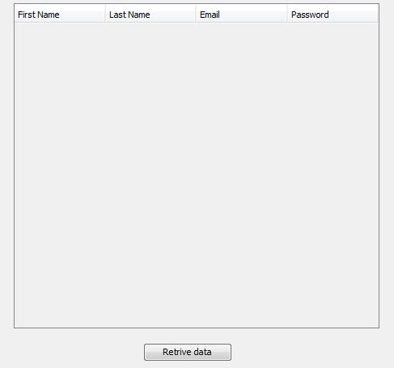

CODING

private void jButton1ActionPerformed(java.awt.event.ActionEvent evt) {

DefaultTableModel model=(DefaultTableModel)rp1.getModel();

try{

class.forName("java.sql.Driver");

Connection con=DriverManager.getConnection("jdbc:mysql://localhost/rohit","root","rohit");

Statement stmt=con.createStatement();

String query="SELECT*from register;";

ResultSet rs=stmt.executeQuery(query);

while(rs.next()){

String fn=rs.getString("First_Name");

String ln=rs.getString("Last_Name");

String em=rs.getString("Email");

String ps=rs.getString("Password");

model.addRow(new Object[]{fn,ln,em,ps});

}

rs.close();

stmt.close();

con.close();

}

catch(Exception e){

JOptionPane.showMessageDialog(null,"error in connectivity");